Code : 1
import cv2
import numpy as np
image = cv2.imread('1.jpeg')
if image is None:
print("Error: Could not load 1.jpg")
exit()
kernel_size = (5, 5)
sigma = 1.5
gaussian_1d = cv2.getGaussianKernel(5, sigma)
gaussian_kernel = np.outer(gaussian_1d, gaussian_1d)
smoothed_image = cv2.filter2D(image, -1, gaussian_kernel)
sharpening_kernel = np.array([
[-1, -1, -1],
[-1, 9, -1],
[-1, -1, -1]
])
sharpened_image = cv2.filter2D(image, -1, sharpening_kernel)
cv2.imshow("Original Image", image)
cv2.imshow("Smoothed Image", smoothed_image)
cv2.imshow("Sharpened Image", sharpened_image)
cv2.waitKey(0)
cv2.destroyAllWindows()

Output :

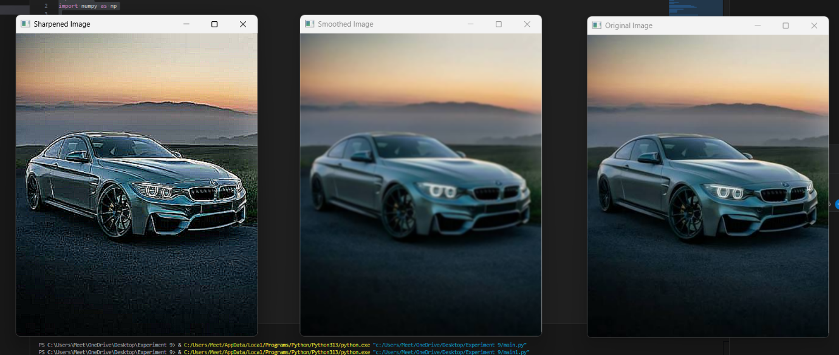

Code : 2
import cv2
import numpy as np
image = cv2.imread('1.jpeg')
if image is None:
print("Error: Could not load 1.jpeg")
exit()
kernel_size = (5, 5)
kernel = np.ones(kernel_size, dtype=np.float32) / (
kernel_size[0] * kernel_size[1]
)
smoothed_image = cv2.filter2D(image, -1, kernel)
cv2.imshow("Original Image", image)
cv2.imshow("Smoothed Image", smoothed_image)
cv2.waitKey(0)
cv2.destroyAllWindows()

Output :
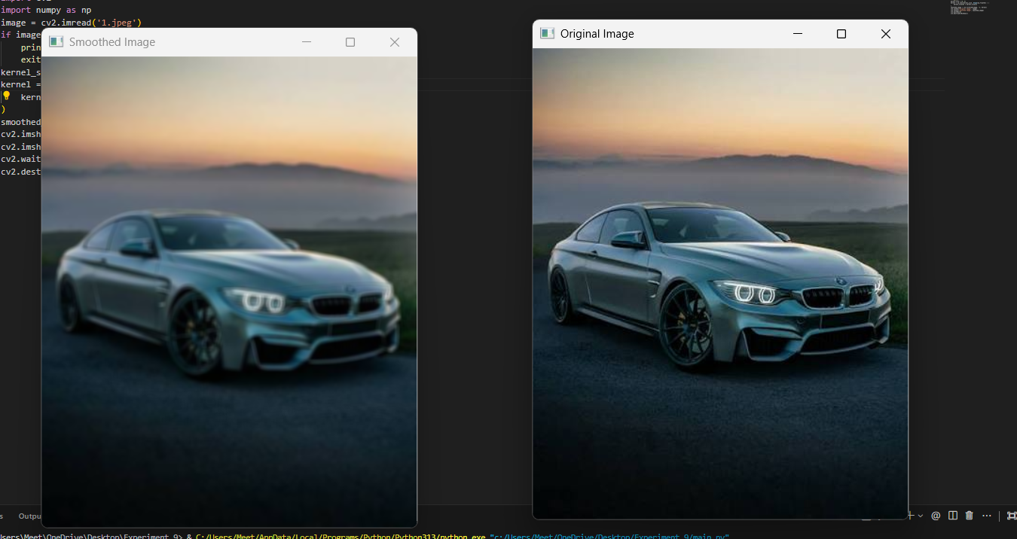

Code 3:
import cv2
import numpy as np
image = cv2.imread('1.j peg')
if image is None:
print("Error: Could not load 1.jpeg")
exit()
kernel_size = 5
smoothed_image = cv2.medianBlur(image, kernel_size)
cv2.imshow("Original Image", image)
cv2.imshow("Median Filtered Image", smoothed_image)
cv2.waitKey(0)
cv2.destroyAllWindows()

Output :
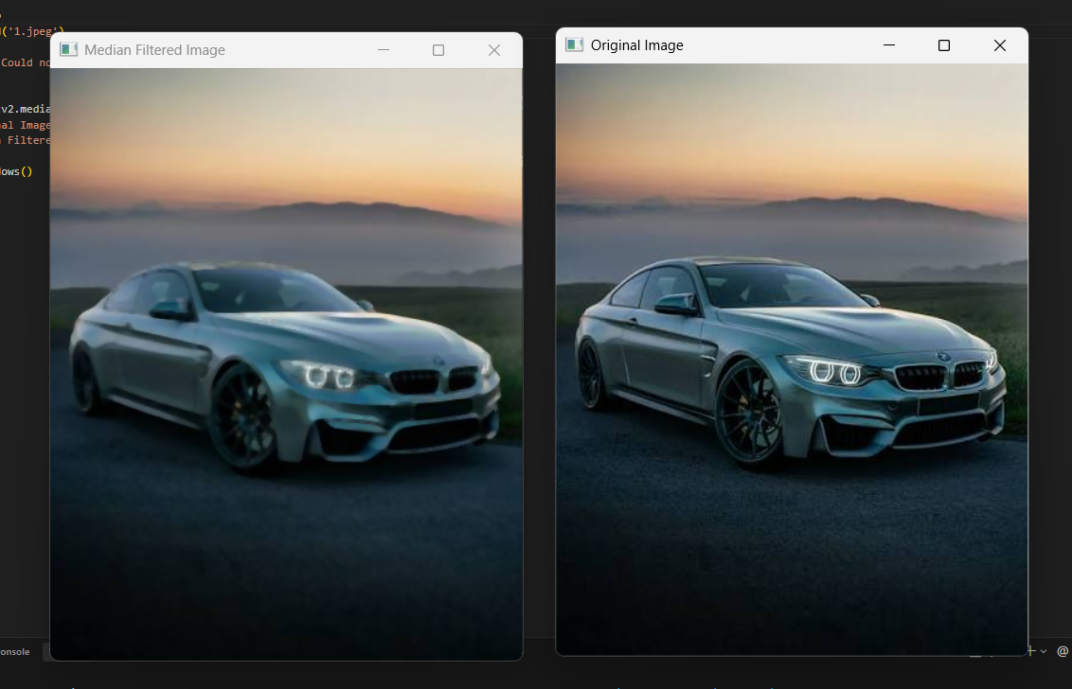

Code 4 :
import cv2
import numpy as np
image = cv2.imread('1.jpeg')
if image is None:
print("Error: Could not load 1.jpeg")
exit()
blurred_image = cv2.GaussianBlur(image, (5, 5), 0)
laplacian_kernel = np.array([
[0, -1, 0],
[-1, 5, -1],
[0, -1, 0]
], dtype=np.float32)
sharpened_image = cv2.filter2D(
blurred_image, -1, laplacian_kernel
)
cv2.imshow("Original Image", image)
cv2.imshow("Blurred Image", blurred_image)
cv2.imshow("Sharpened Image", sharpened_image)
cv2.waitKey(0)
cv2.destroyAllWindows()

Output :
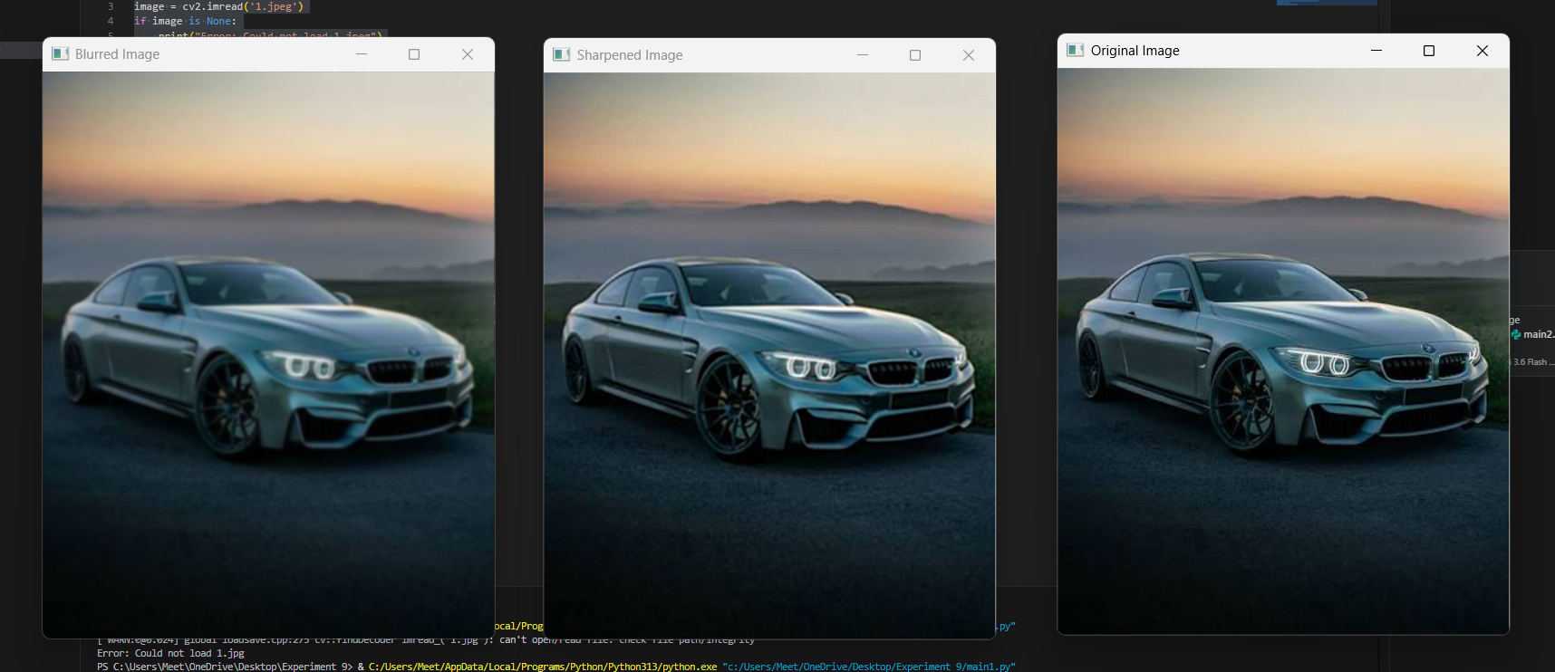
Conclusion :
Different image filtering techniques are useful for improving image quality in different ways. Gaussian filtering gives a smooth and natural blur while preserving important edges. Averaging filtering is simple and reduces noise, but it can make the image look less detailed. Median filtering is very effective for removing salt-and-pepper noise while keeping the edges clear. Sharpening filters enhance edges and make the image look clearer and more detailed. Combining Gaussian smoothing with Laplacian sharpening can first reduce noise and then improve the sharpness of the image. Overall, no single filter is best for every situation. The choice of filter depends on the type of noise, the required image quality, and the final purpose of the image.

